NAME:ZOHA AHMED

ROLLNO:23I-2555

QUESTION#1:

#include <iostream>

#include <string>

using namespace std;

class Book {

protected:

    string title;

    string author;

    string publisher;

public:

    Book(string title, string author, string publisher)

        : title(title), author(author), publisher(publisher) {}

    void display() {

        cout << "Title: " << title << endl;

        cout << "Author: " << author << endl;

        cout << "Publisher: " << publisher << endl;

    }

};

class FictionBook : public Book {

private:

    string genre;

    string protagonist;

public:

    FictionBook(string title, string author, string publisher, string genre, string protagonist)

        : Book(title, author, publisher), genre(genre), protagonist(protagonist) {}

    void display() {

        Book::display();

        cout << "Genre: " << genre << endl;

        cout << "Protagonist: " << protagonist << endl;

    }

};

int main() {

    FictionBook fiction("The Great Gatsby", "F. Scott Fitzgerald", "Scribner", "Fiction", "Jay Gatsby");

    fiction.display();

    return 0;

}

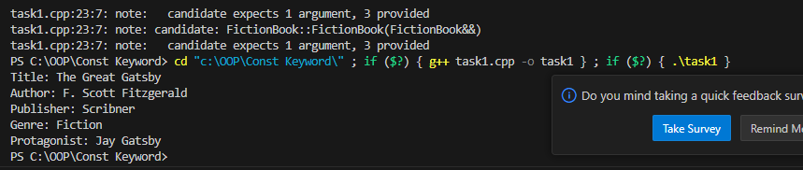

Question#2:

#include <iostream>

#include <string>

using namespace std;

class Character {

protected:

    int health;

    int damage;

public:

    Character(int health, int damage)

        : health(health), damage(damage) {}

    void display() {

        cout << "Health: " << health << endl;

        cout << "Damage: " << damage << endl;

    }

};

class Enemy : public Character {

public:

    Enemy(int health, int damage)

        : Character(health, damage) {}

    void display() {

        cout << "Enemy Details:" << endl;

        Character::display();

    }

};

class Player : public Character {

public:

    Player(int health, int damage)

        : Character(health, damage) {}

    void display() {

        cout << "Player Details:" << endl;

        Character::display();

    }

};

class Wizard : public Player {

private:

    int magicPower;

    string spells;

public:

    Wizard(int health, int damage, int magicPower, string spells)

        : Player(health, damage), magicPower(magicPower), spells(spells) {}

    void display() {

        cout << "Wizard Details:" << endl;

        Player::display();

        cout << "Magic Power: " << magicPower << endl;

        cout << "Spells: " << spells << endl;

    }

};

int main() {

    Wizard wizard(100, 20, 50, "Fireball, Lightning Bolt");

    wizard.display();

    return 0;

}



QUESTION #3:

#include <iostream>

using namespace std;

class Position {

protected:

    float x, y, z;

public:

    Position(float x, float y, float z) : x(x), y(y), z(z) {}

    void displayPosition() {

        cout << "Position: (" << x << ", " << y << ", " << z << "")" << endl;

    }

};

class Health {

protected:

    int health;

public:

    Health(int health) : health(health) {}

    void displayHealth() {

        cout << "Health: " << health << endl;

    }

};

class Character : public Position, public Health {

private:

    string name;

public:

    Character(float x, float y, float z, int health, string name)

        : Position(x, y, z), Health(health), name(name) {}

    void displayCharacter() {

        cout << "Character Name: " << name << endl;

        displayPosition();

        displayHealth();

    }

};

int main() {

    Character player(10.0f, 5.0f, 3.0f, 100, "Player1");

    player.displayCharacter();

    return 0;

}

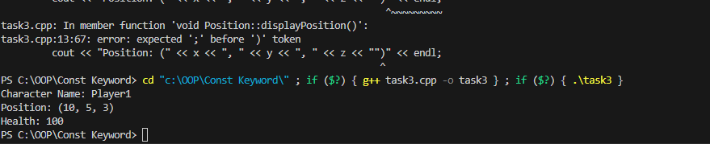

QUESTION #4:

#include <iostream>

#include <string>

using namespace std;

class Person {

protected:

    string name;

    int age;

public:

    Person(string name, int age) : name(name), age(age) {}

    void display() {

        cout << "Name: " << name << ", Age: " << age;

    }

};

class Student : virtual public Person {

protected:

    int studentID;

    int gradeLevel;

public:

    Student(string name, int age, int studentID, int gradeLevel)

        : Person(name, age), studentID(studentID), gradeLevel(gradeLevel) {}

    void displayStudent() {

        display();

        cout << ", Student ID: " << studentID << ", Grade Level: " << gradeLevel << endl;

    }

};

class Teacher : virtual public Person {

protected:

    string subject;

    int roomNumber;

public:

    Teacher(string name, int age, string subject, int roomNumber)

        : Person(name, age), subject(subject), roomNumber(roomNumber) {}

    void displayTeacher() {

        display();

        cout << ", Subject: " << subject << ", Room Number: " << roomNumber << endl;

    }

};

class GraduateStudent : public Student, public Teacher {

public:

    GraduateStudent(string name, int age, int studentID, int gradeLevel, string subject, int roomNumber)

        : Person(name, age), Student(name, age, studentID, gradeLevel), Teacher(name, age, subject, roomNumber) {}

    void displayGraduateStudent() {

        display();

        cout << ", Student ID: " << studentID << ", Grade Level: " << gradeLevel

             << ", Subject: " << subject << ", Room Number: " << roomNumber << endl;

    }

};

int main() {

    GraduateStudent gradStudent("zoha", 25, 12345, 12, "Math", 101);

    gradStudent.displayGraduateStudent();

    return 0;

}

